# Programming Fundamentals and Unit Testing Regular Exam – 2 March 2025

Submit your zip file here: <https://judge.softuni.org/Contests/5375/Programming-Fundamentals-and-Unit-Testing-Regular-Exam-2-March-2025>

# 4. Unit Test List: Consonants Counter

Test a given method which takes in a **list of strings and returns the total number of consonants** found in the list. The program considers **consonants to be 'b', 'c', 'd', 'f', 'g', 'h', 'j', 'k', 'l', 'm', 'n', 'p', 'q', 'r', 's', 't', 'v', 'w', 'x', 'y', 'z' (both uppercase and lowercase)**.

The method is found in the **ConsonantsCounter**.cs file:

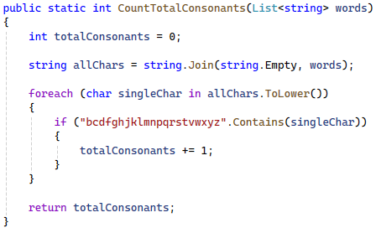

You are given a **test** **file** **ConsonantsCounterTests**.cs containing **5 empty tests**. Implement all the unit tests:

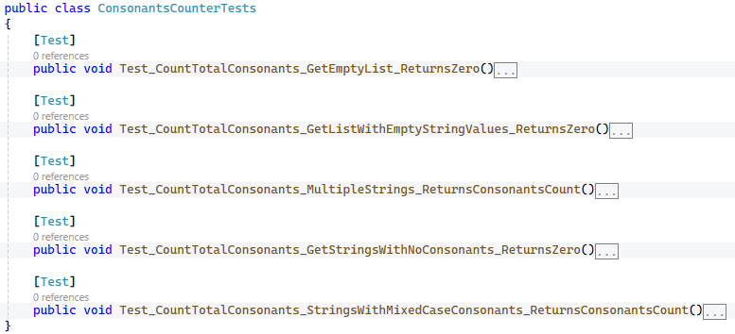

When you are ready make sure your **tests run:**

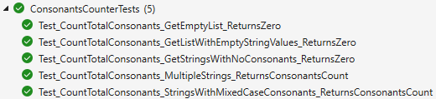

**IMPORTANT:** **DO NOT REMOVE OR CHANGE ANY NAMESPACES AND USINGS.**